**Salesforce Packager Manual**

Contents

Installation Step 2

Adding Instances 2

Create Deployment 4

Adding Components 6

Generating Packages 8

Supported Metadata 10

Tool – Profile Cleanup 13

## Installation Step

Run the Setup.exe, once installation completed the application will be executed.

## Adding Instances

Run the Application

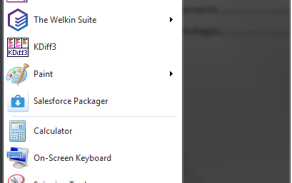

Click on the **settings**

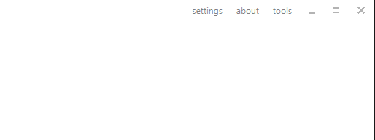

Click on the Add Instance

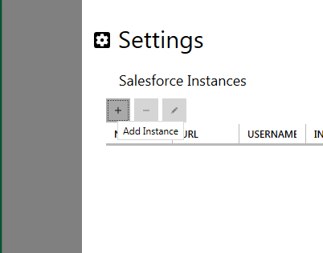

Specify details in all the fields and click Save

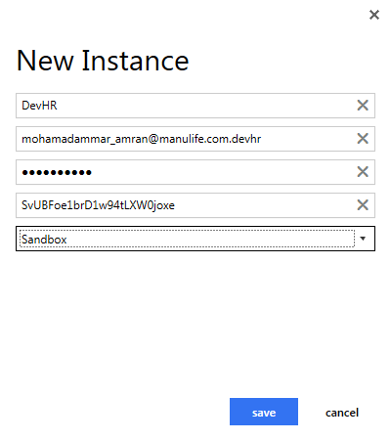

Click ok



Restart the application for the changes to take effect

## Create Deployment

Click the **New Project** button

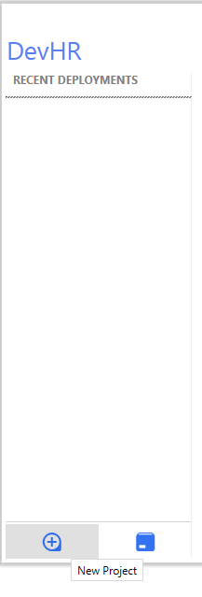

Specify the details

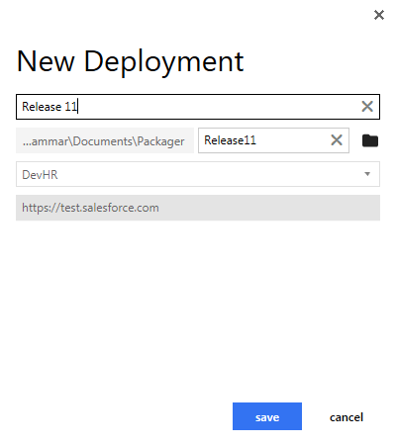

Click Save

## Adding Components

Click on the Deployments project and Click the Component button

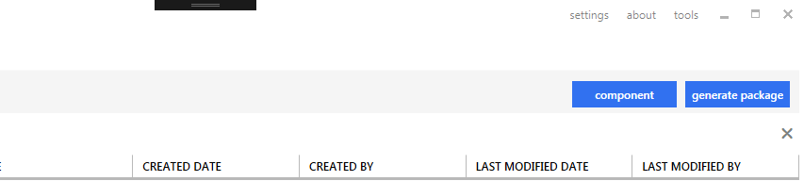

Select component to be added from the dropdown, another list of components will populate based on the type selected

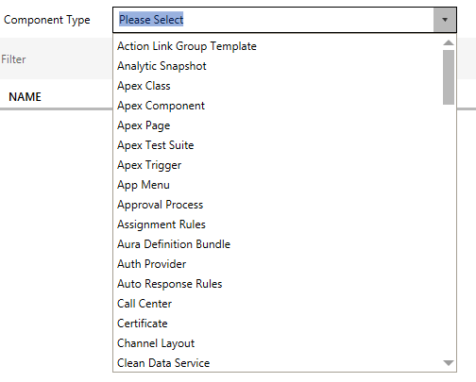

Select the components and click add

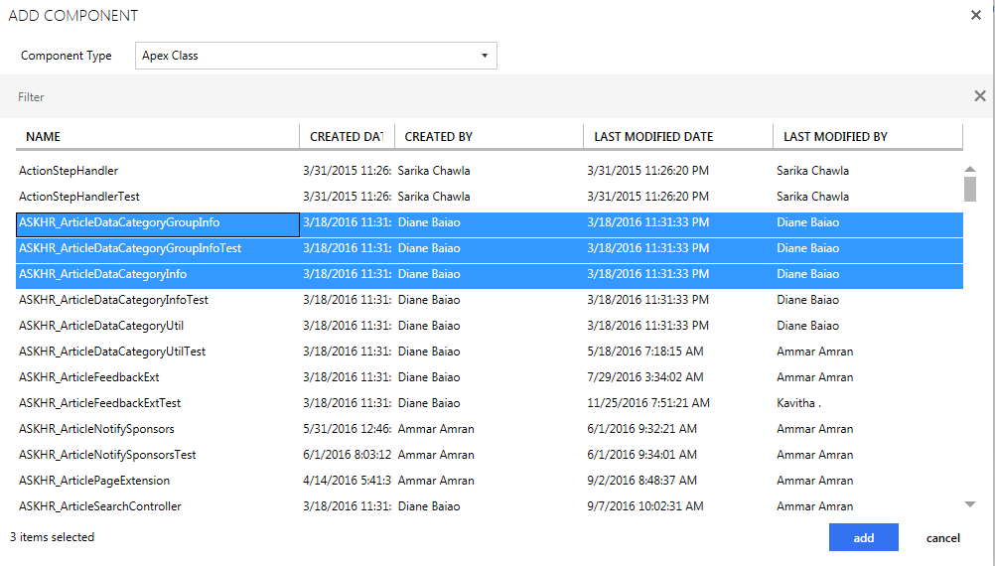

The components will be added to the project

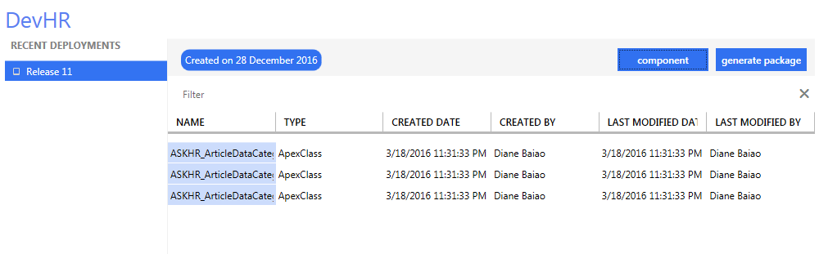

## Generating Packages

Click on the Deployments project and Click the generate package button

Note: the deployment project must contains components in order to generate the package

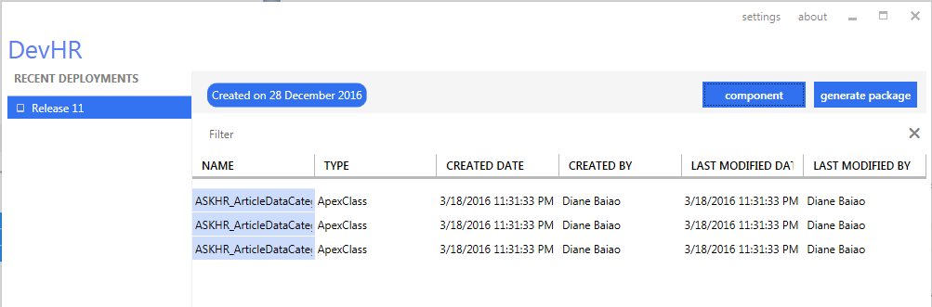

In progress

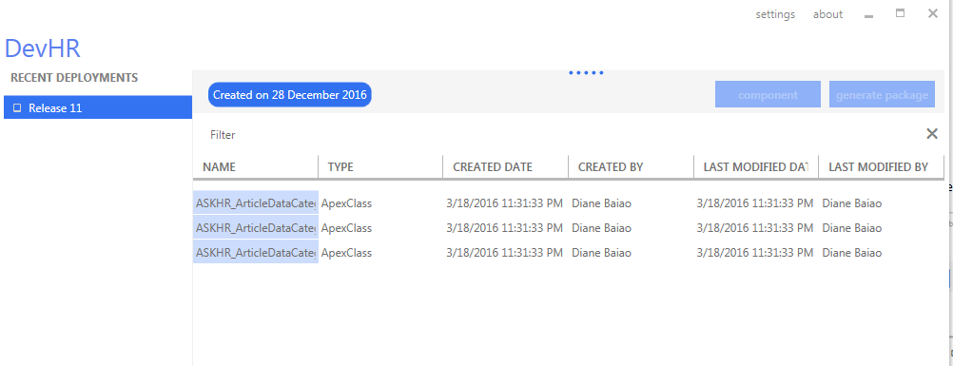

Once complete, right click on the project and select Show in Explorer

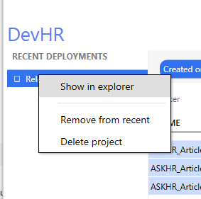

The components is stored inside the Package folder

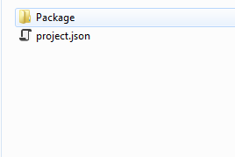

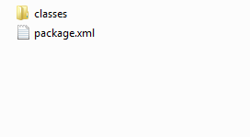

## Supported Metadata

The following metadata are supported by this application to generate the package

1. Action Link Group Template
2. Analytic Snapshot
3. Apex Class
4. Apex Component
5. Apex Page
6. Apex Test Suite
7. Apex Trigger
8. App Menu
9. Approval Process
10. Assignment Rules
11. Aura Definition Bundle
12. Auth Provider
13. Auto Response Rules
14. Call Center
15. Certificate
16. Channel Layout
17. Clean Data Service
18. Community
19. Community Template Definition
20. Community Theme Definition
21. Connected App
22. Content Asset
23. Cors Whitelist Origin
24. Custom Application
25. Custom Application Component
26. Custom Field
27. Custom Label
28. Custom Metadata
29. Custom Object
30. Custom Object Translation
31. Custom Page Web Link
32. Custom Permission
33. Custom Site
34. Custom Tab
35. Dashboard
36. Dashboard Folder
37. Data Category Group
38. Delegate Group
39. Document
40. Document Folder
41. Duplicate Rule
42. Email Folder
43. Email Template
44. Embedded Service Config
45. Entitlement Process
46. Entitlement Template
47. Escalation Rules
48. External Data Source
49. Flexi Page
50. Global Value Set
51. Global Value Set Translation
52. Group
53. Home Page Component
54. Home Page Layout
55. Installed Package
56. Keyword List
57. Layout
58. Letterhead
59. Matching Rules
60. Milestone Type
61. Moderation Rule
62. Named Credential
63. Network
64. Path Assistant
65. Permission Set
66. Platform Cache Partition
67. Portal
68. Profile
69. Queue
70. Quick Action
71. Remote Site Setting
72. Report
73. Report Folder
74. Report Type
75. Role
76. Saml SSO Config
77. Scontrol
78. Settings
79. Sharing Criteria Rule
80. Sharing Owner Rule
81. Sharing Rules
82. Sharing Territory Rule
83. Site Dot Com
84. Standard Value Set
85. Standard Value Set Translation
86. Static Resource
87. Synonym Dictionary
88. Translation
89. Validation Rule
90. Workflow
91. Workflow Alert
92. Workflow Field Update
93. Workflow Outbound Message
94. Workflow Rule
95. Workflow Task

The following metadata is not supported-

1. Flow
2. Flow Definition

Note: this metadata is purposely removed as ANT does not fully supported deployment of Flow (flow and process builder)

## Tool – Profile Cleanup

ANT tool does not support for deploying Profile metadata as is, as highlighted in the known issue Summer 14 – Force.com project fails with “Unknown User Permission” <https://success.salesforce.com/issues_view?id=a1p30000000T5a8AAC>

A workaround is to remove all the <userPermissions> sections and deploy the Profile metadata.

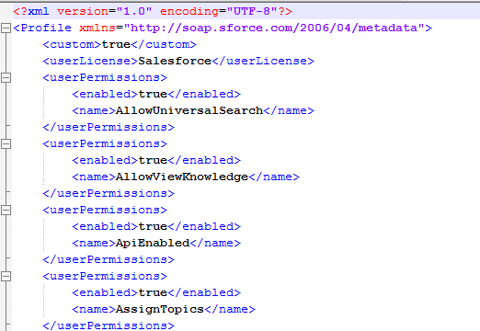

To ease removal of the sections especially for large number of Profile metadata, use the tool Profile cleaner from the tools section

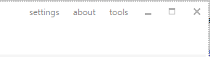

Profile Cleaner

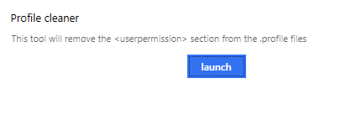

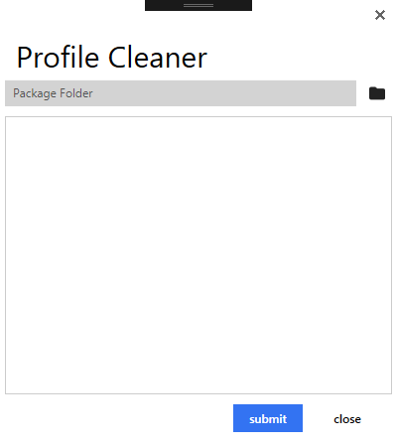

Steps:

1. Select the project folder (this is the project folder that contains the Package and the project.json)

e.g: C:\Users\mohamadammar\Documents\Packager\profilesonly

2. Click Submit  
3. Once completed will show result

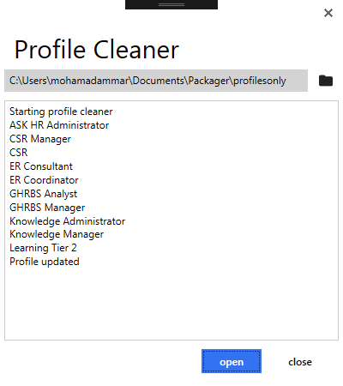

And all the .profile files in the Profile folder will be cleaned up as below

